*SLING RESOURCE MERGER*

***sling:hideProperties***

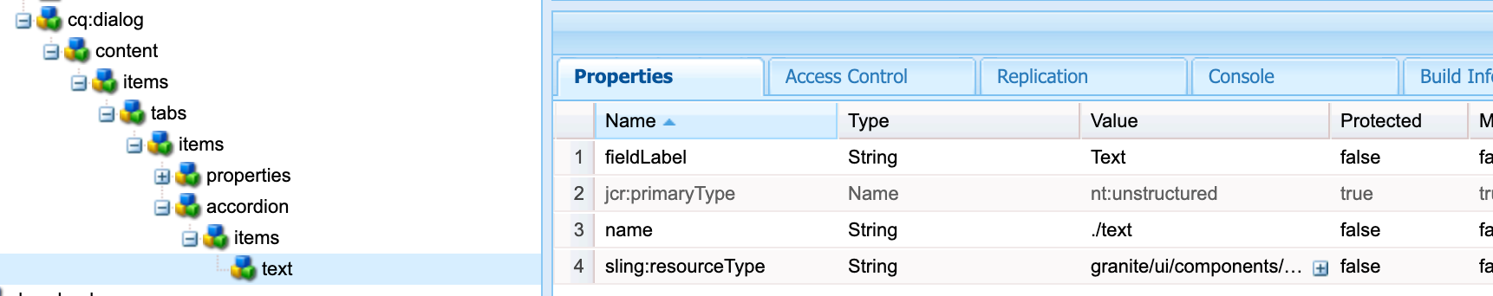



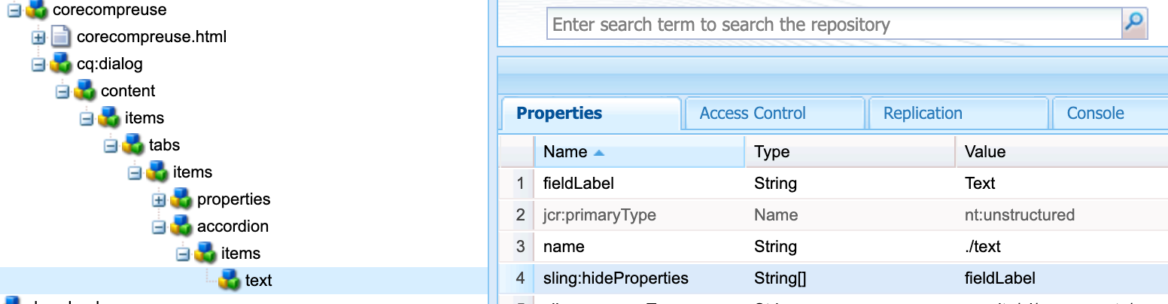



***sling:hideResource***

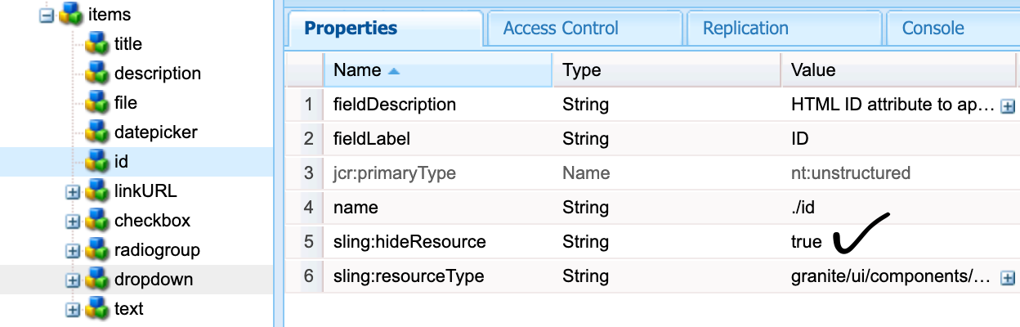

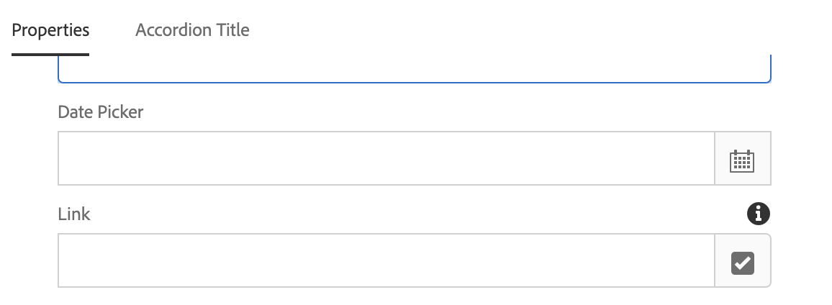

***sling:orderBefore***

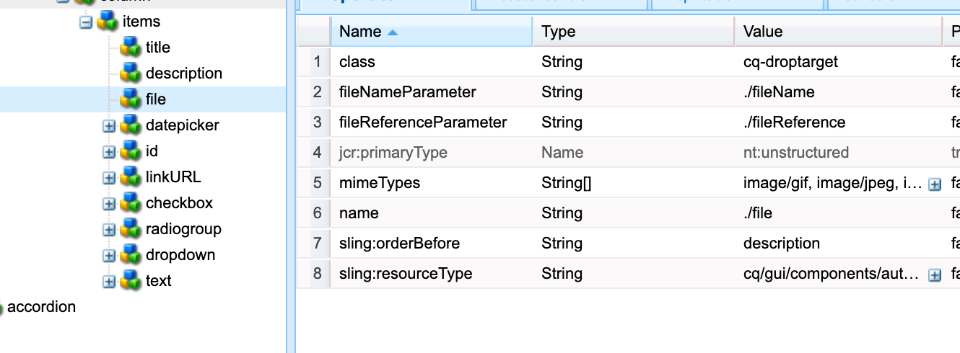

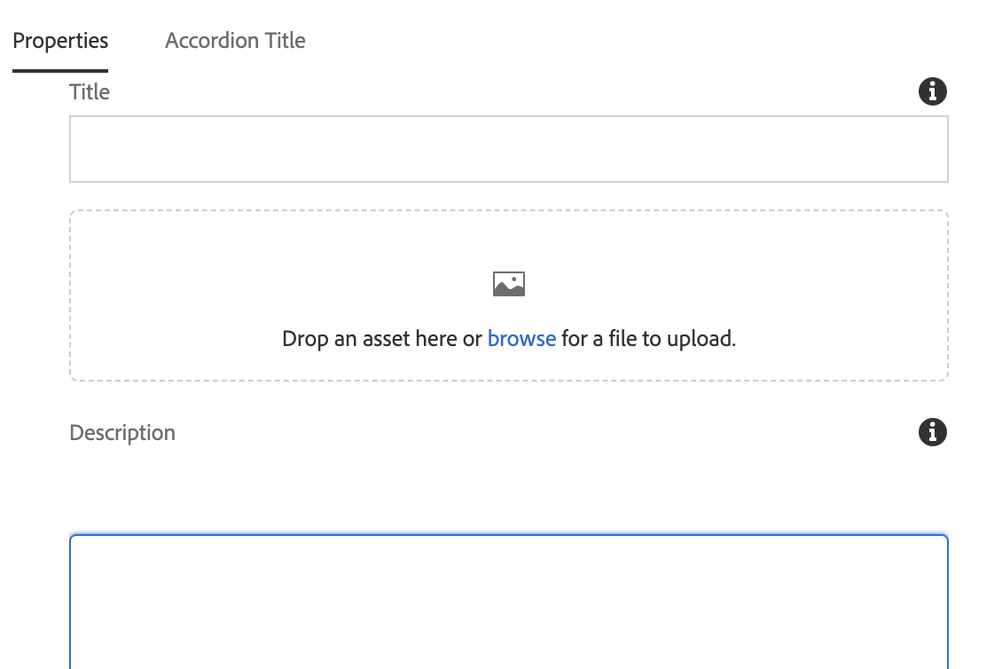

***sling:hideChildren***